Pizza GUI

Objectives

* Interact with radio buttons, button groups, check boxes, text boxes
* Use layout managers
* Scrape screen
* Use a class to store form data

# Build a new project

* Name it LuigiPizza
* Delete the main file
* Create a new JFrame named OrderGUI
* Run it – the first run can take a minute
* Make the frame bigger
* Add the top label
  + Demonstrate snapping
  + Center Luigi’s Pizza
  + Demonstrate how to remove accidental event
    - Properties, event - remove
* Add radio buttons
  + Demonstrate the problem without a button group
  + Add a button group – sizeGroup
    - Look ma, it’s invisible
  + Set a default in properties
  + Add a label if desired
  + Add sauce radio, set default in code
* Toppings
  + We will have six toppings
  + Will use a panel and a layout manager to arrange neatly
  + Add a panel to the form, name it toppingPanel ( I am coloring it red for now for visibility)
  + Change the layout to grid
  + Open navigator, set properties of the grid
  + If need to move after filling, easiest to add a row to the grid then move it
* Add a combo box for specials
  + These will allow you to hit a drop down and select a premade pizza
  + 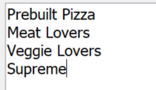Add this model
* Labels for price and total price
* Add buttons for Add to Order, New Order
* Add a list called pizzaList
  + Remove everything from the list model

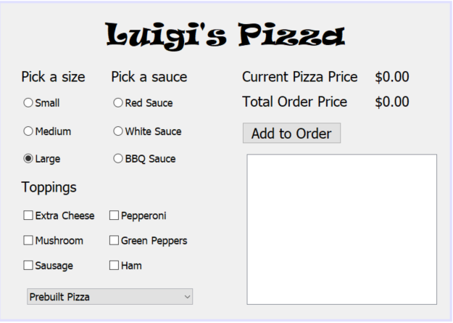

* Create an event handler for the combo box
  + Create a clear toppings method – just to show that you can build custom methods
  + 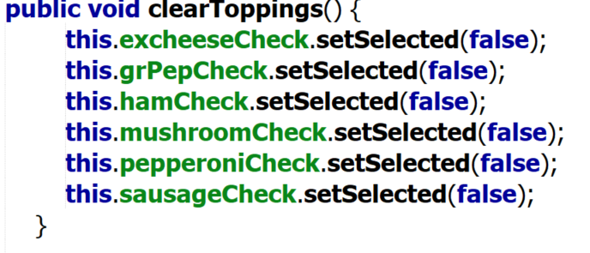
  + Now code the event handler
  + Define the getSelectedIndex  
    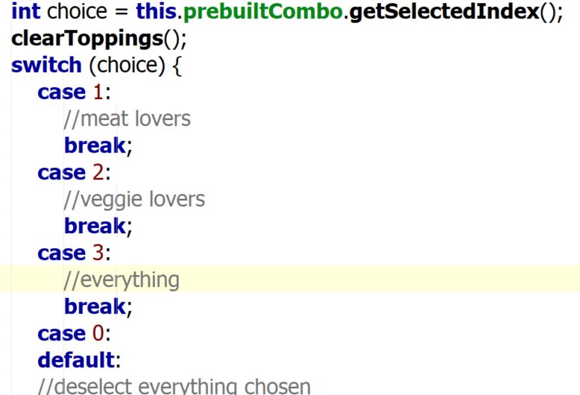
  + Add the cases
  + 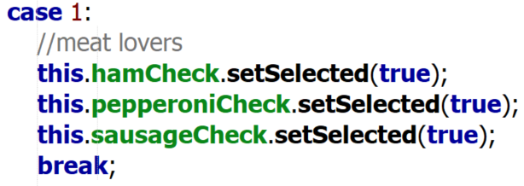
  + 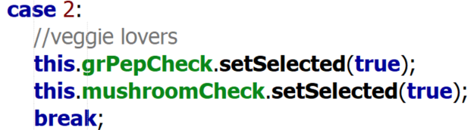
  + Case 3 checks them all
* Create a Pizza class to handle the order and calc the price
  + 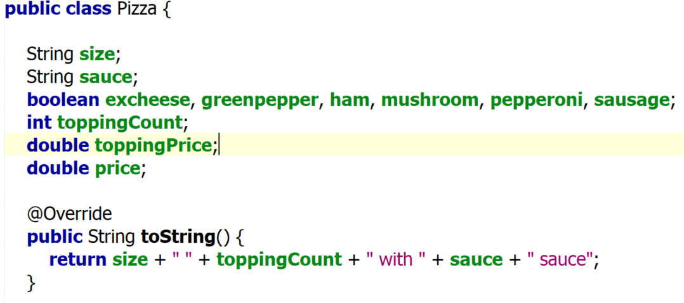
  + 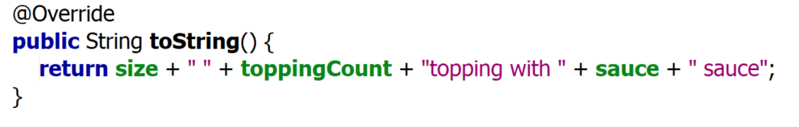
  + Now create the constructor to calculate the cost
    - Create a blank default
    - Will use to build price each time something is changed
    - Create constructor with parameters (not toppingCount, toppingPrice, price)



* + Calculate the price and topping price

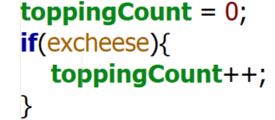

Repeat for each topping

End with

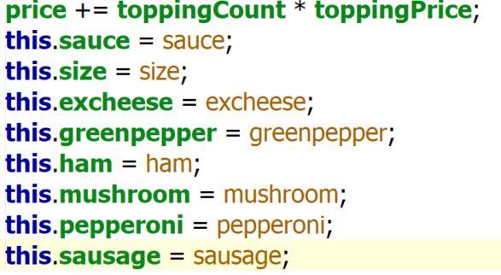

**Add setters and getters – read the names**

# Now calc cost in the GUI

* Add to the main, at the bottom after other variables (can be anywhere, put here for consistency)
* **Set total cost = 0**
* 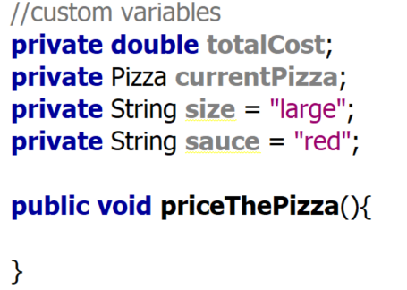
* Code the method
* 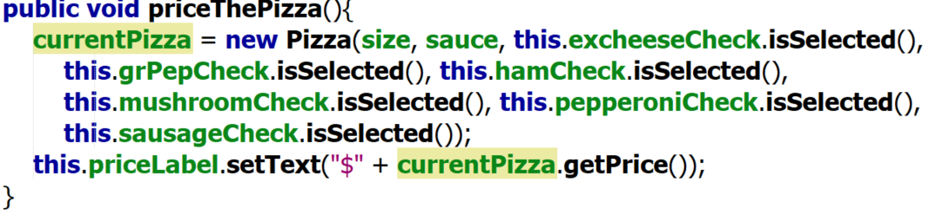
* Code each radio button – repeat for each as appropriate
* 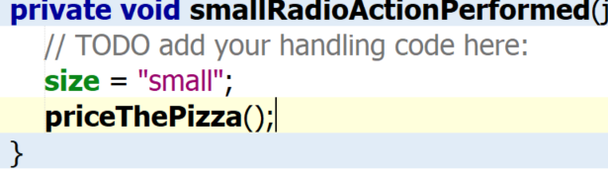
* Run and ensure it works – will fix decimal output later
* Code each check box with just a call to price
* 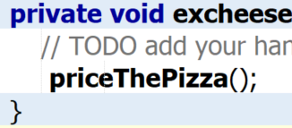
* Run demonstrate the ‘error’ with prebuilt pizzas
  + Call at the bottom of the prebuilt

# Handle adding to the order – this will be a list of pizzas

1. Create a model for the list – properties of list
2. Set the type of the list to your object
3. 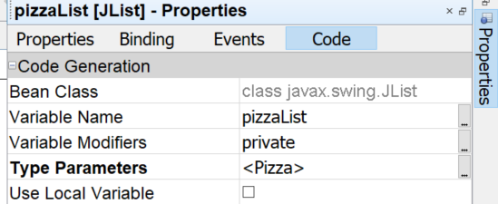
4. In your variable section add a DefaultListBoxModel that references the <Pizza> object
5. This model will hold objects of type Pizza
6. 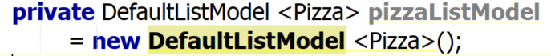
7. It will display your toString
8. In your Form constructor, add this line AFTER initComponents
9. 
10. Go to the Add To Order Button and add these lines of code

# Select a pizza

* Add an event to the list – double click does not work, need to select an event
  + Rt click the list | Events | list Selection | valueChanged

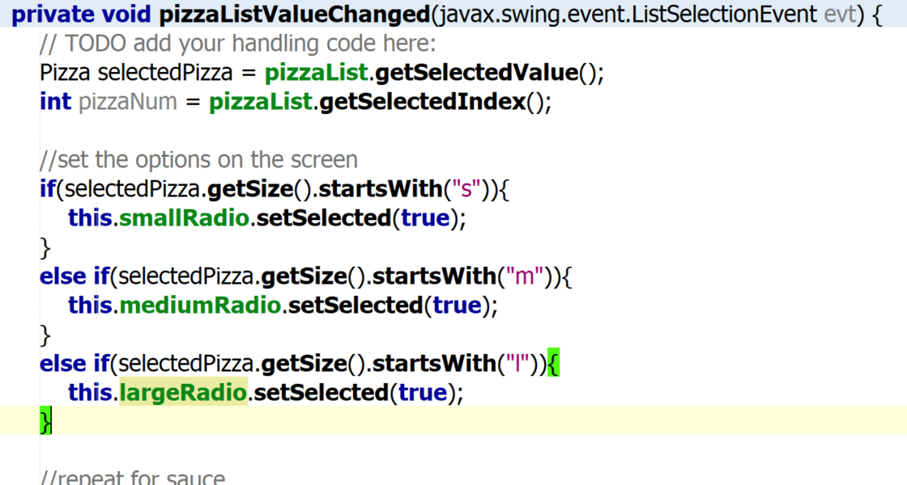  
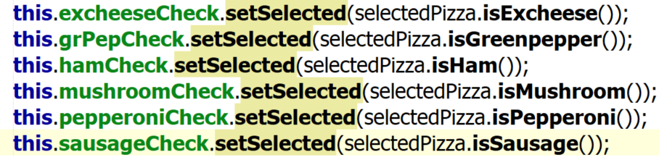

Add priceThePizza here

# If you have extra time, add in the remove and update buttons

Update – need to move the selected pizza and pizza num global

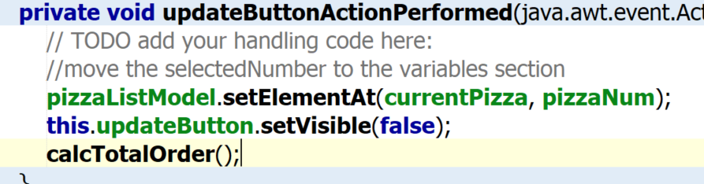

Modify addOrder

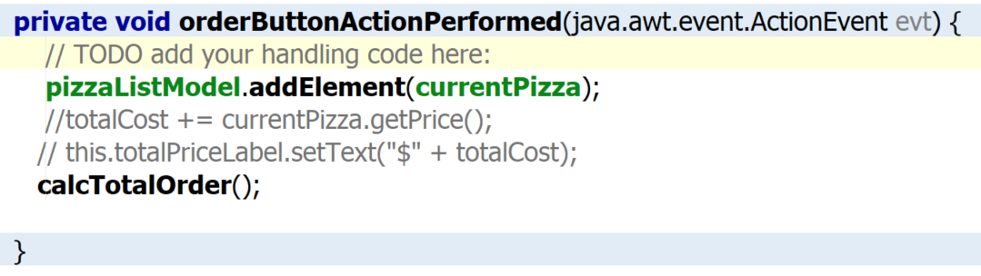

Also need to create a calcTotalOrder method

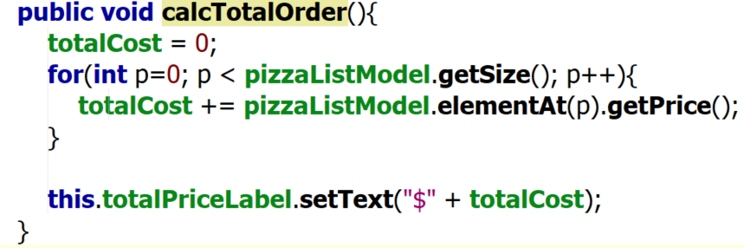

Remove

